**Object Oriented Design Project**

**Group 3**

**Parking Management System**

|  |  |
| --- | --- |
| Student Name | Student Number |
| Aljawharah Almedbel | 444011180 |
| Sara Aljarba | 444009199 |
| Lama Alshaiban | 444009259 |
| Hala Almansour |  |
| Yara Alharthi | 444009258 |

**Functional Requirements** 4

**Use Case Diagram** 5

**High-Level Use Case Diagram** 6

**Expanded Use Case Description** 8

**Class Diagram** 10

**zActivity Diagrams** 11

**Sequence Diagram** 14

**Component Diagram** 15

Project Overview

The purpose of the Parking Management System (PMS) is to optimize and improve the effectiveness of parking spot utilization in commercial spaces, and large facilities. Effective parking solutions are becoming increasingly important as the population and number of vehicles on the road rise. Issues like crowding, wasteful parking, and the absence of real-time information for users are all intended to be resolved by this approach. The PMS will offer a user-friendly interface for parking operators and parkers alike by incorporating cutting-edge technology including automatic notifications, real-time data analytics, and mobile applications. The ultimate objective is to maximize parking space use, lessen traffic, and enhance consumers' overall parking experiences.

**Scope of the System**

A variety of services will be provided by the parking management system to enhance user satisfaction and operational effectiveness. User registration and account management, which allow for the creation and management of accounts with safe login and logout choices, are important aspects. With the help of Real-Time Availability Tracking, users may search for parking spaces by location, date, and time. In addition to a payment processing service that takes a variety of payment ways and generates electronic receipts, the system will enable reservation functionality for reservations made in advance. While a user feedback mechanism will gather information on experiences, a notification system will notify users of reservations and expirations. Inquiries will also be answered by a Help and Support Section. In order to maximize total parking management services and ensure ease, the PMS will be available through a mobile application.

## **Functional Requirements**

**Functional Requirements**

1. User Registration and Account Management: Users must be able to create, edit, and delete their accounts, with password recovery options available.

2. Login and Logout: Users should securely log in and out of the system.

3. Search for Parking Spaces: Users can search for available parking spots based on location, date, and time.

4. Real-Time Availability Tracking: The system must provide real-time updates on parking space availability.

5. Reservation Functionality: Users can reserve parking spaces in advance and receive confirmation notifications for their reservations.

6. Payment Processing: The system must support multiple payment methods (credit/debit cards, mobile payments), and users should receive electronic receipts for payments.

7. Notification System: Users should receive notifications for reservation confirmations, reminders, and expirations.

8. User Feedback Mechanism: Users can submit feedback regarding their parking experience, and administrators can review and respond.

9. Help and Support Section: The system must provide a help section for user inquiries and support.

10. Mobile Application Access: The system must be accessible via a mobile application for user convenience.

### **Use Case Diagram**

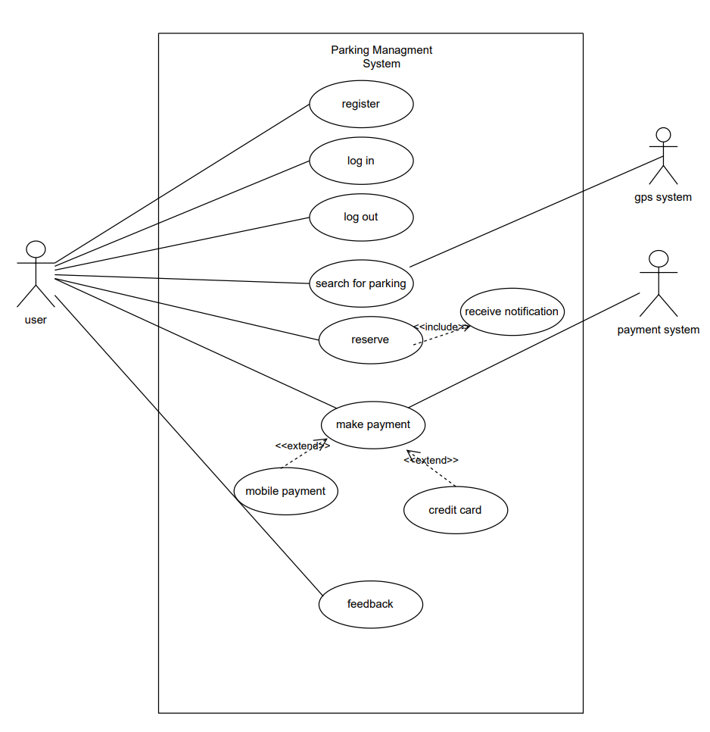

#### **High-Level Use Case Diagram**

1.Use Case: Register  
• Actors: User  
• Description: Allows the user to register in the system by entering their basic information such as name, email, and password.  
  
2. Use Case: Log In  
• Actors: User  
• Description: Allows the user to log into the system using their credentials (email and password).  
  
3. Use Case: Log Out  
• Actors: User  
• Description: Allows the user to log out of the system after completing their session, thereby terminating the current session.  
  
4. Use Case: Search for Parking  
• Actors: User, GPS System  
• Description: Allows the user to search for available parking spots based on their current location, determined by the GPS system.  
  
5. Use Case: Reserve  
• Actors: User  
• Description: Allows the user to reserve a parking spot after selecting an available spot based on location or price.  
  
6. Use Case: Receive Notification  
• Actors: User  
• Description: Sends a notification to the user when the reservation is confirmed or when there is any status update.

7. Use Case: Make Payment  
• Actors: User, Payment System  
• Description: Allows the user to pay the reservation fee using one of the available payment methods, such as credit card or mobile payment.  
  
8. Use Case: Mobile Payment  
• Actors: User, Payment System  
• Description: Allows the user to make a payment via mobile payment systems like wallets or mobile apps.

9. Use Case: Credit Card  
• Actors: User, Payment System  
• Description: Allows the user to make a payment using a credit card through the system.  
  
10. Use Case: Feedback  
• Actors: User  
• Description: Allows the user to provide feedback or rate the service they received, helping improve the system or service.

##### **Expanded Use Case Description**

Use case: Search for Parking

Actor: User, GPSsystem Purpose: Allow the user to search for available parking spots. Overview: The use case begins when the user wants to search for a parking spot. The GPS System provides the user’s location to the system, which then displays available spots nearby. The user selects a suitable spot based on location or other preferences. Type: primary Typical course of event:

|  |  |
| --- | --- |
| System response | Actor |
| 2.determine the user location via gps. | 1. Starts searching for a parking spot. |
| 3. Displays available parking spots. |  |
| 5. Displays details and reserves the spot. | 4.Selects a spot based on preferences |
| 7. Processes payment and prints the receipt | 6. Chooses a payment method. |

**Alternatives:**

Line 2: If GPS is unavailable, notify the user.  
  Line 3: If no spots are available, inform the user.  
  Line 7: If payment is canceled, the system cancels the reservation

Use case: Reserve Parking

Actor: user

Purpose: Allow the user to reserve a parking spot.

Overview: The use case begins when the user wants to reserve a specific parking spot after searching for it. The system reserves the spot and sends a confirmation of the reservation to the user

Type: primary Typical course of event:

Typical course of event:

|  |  |
| --- | --- |
| System response | Actor |
| 2. Displays reservation details and the amount due | 1. User initiates the reservation process for a parking spot |
| 4. Confirms the reservation and sends a notification containing the reservation details to the use | 3. User confirms the reservation. |

Alternatives:

Line 3: If the reservation is canceled before confirmation, the system terminates the process and no reservation is made

###### **Class Diagram**

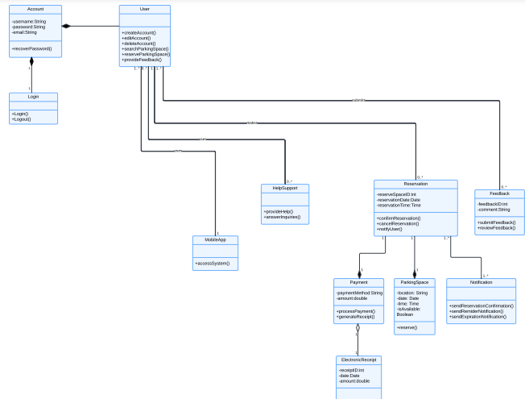

**Activity Diagrams**

1. 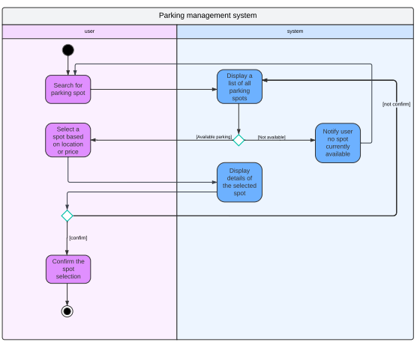**Search For Parking**
2. **Reserve Parking**

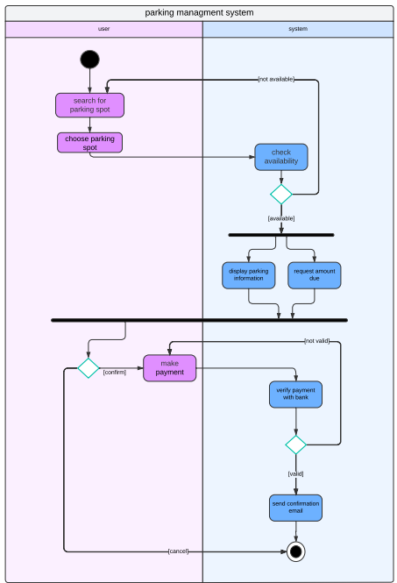

**Sequence Diagram**

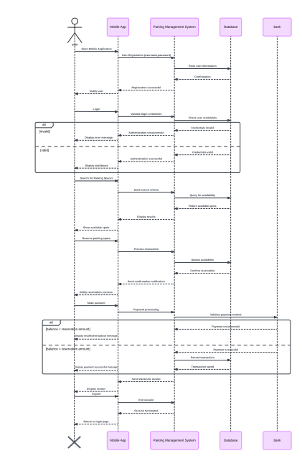

**Component Diagram**